**六年级上英语Unit4 I have a pen pal 第3课时试题**



**B Let's try & Let's talk**

1. 翻译。
2. 对…感兴趣 ________ 2. 住在澳大利亚 ___________

3. 猜字谜 ____________ 4. 写电子邮件 ____________

5. 去远足 ____________ 6. 为什么不呢？___________

二、选出发音不同的一项。[来源:Zxxk.Com]

（ ）1. A.shirt B. girl C.sister

（ ）2. A.Thursday B.earth C.colour

（ ）3. A.learn B.teacher C.colour



（ ）4.A.head B. bread C.meat

（ ）5.A.ruler B.pleasure C.eraser



（ ）6.A.egg B.head C.apple



1. 连词成句。
2. something tell your pen pal me about .



_______________________________________________

1. like we learning English don’t .

________________________________________________

1. doesn’t he in live Canberra .

_______________________________________________



1. likes he going doing and hiking word puzzles .

_____________________________________________________



1. music he listening likes to .

______________________________________________________



1. 阅读理解。

Dear Alice,

Australia must be fun!

I live in China with my mom and dad . I don’t have a sister or a brother. My mum is a singer . She likes swimming. My dad is a TV reporter . He likes listening to music. I like playing the vio;in and writing emails.[来源:Zxxk.Com]

Your new friend,

Liu Yun

1. What are Lun Yun ‘s hobbies ?

_________________________________________

1. What are her mum’s hobbies ?

_________________________________________

1. What are her dad’s hobbies ?

_________________________________________

1. Does he live with her grandparents ?



_________________________________________



1. Does he have a sister ?

__________________________________________



答案：

一．

1. be interested in[来源:学,科,网Z,X,X,K]

2. live in China

3.do word puzzles

4. write emails

5.go hiking

6. Why not ?

二．

C C A C C C[来源:学科网]

四．

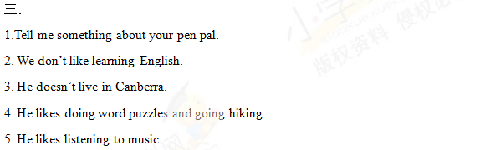

1.She likes playing the vioin and writing emails.

2. She likes swimming.

3. He likes listening to music.



4. No , he doesn’t.

5. No , he doesn’t.